**Resource Use and the Value-Productivity Tradeoff in Australian Winegrowing Regions**

**Introduction**

Viticulture differs from other agricultural pursuits as it is integrated within the wine industry, meaning that when strategies for sustainable viticulture are assessed, there is a trade off between trying to balance the amount of resources invested and the resultant quality and quantity of grapes produced (Montalvo-Falcón et al., 2023). These considerations have become increasingly important within the Australian wine industry due to recent economic, social and environmental pressures, such as bush fires (Wine Australia, 2020), tariffs (Wine Australia, 2022), and shifting attitudes to alcohol consumption (Toumbourou et al., 2018).

There is an extensive amount of research into how a variety of factors effect the outcome of a vineyard’s grape quality and yield, however individual effects are usually studied in isolation (Abbal et al., 2016). Due to a lack of long-term and in-depth data sources, there has been little ability to gain statistical insight at a large scale across multiple regions into vineyards’ resource use and its relationship to vineyards’ outputs (Keith Jones, 2002; Knight et al., 2019). Here we look at the broad effects of resource input and its relation to resultant quality and quantity; where we define quality by the financial value of the grapes per tonne. This analysis looks at these relationships through the use of linear models, using a significantly larger sample size compared to previous research. The analysis includes a multitude of vineyards located over a diverse range of locations and climates, allowing for a more comprehensive understanding of the relationships between resource use and vineyard outputs.

**Methods**

We created four linear models to explore the relationships between resource use and vineyard outputs (see table 1). These models look at the value and quantity of grapes produced by vineyards, as a total and as a scale of area harvested. We compare both values to observe how economies of scale effect the use of resources. The direct relationship between yield and average sale price was reviewed referring to the various models explanation of the determining factors.

**Table 1:** Summary of models, their predictors, covariates and variable interactions.

|  |  |  |  |  |
| --- | --- | --- | --- | --- |
|  | **Response** | **Predictors** | **Covariates** | **Interactions** |
| **Model 1** | Yield | Water Used, Scope 1 Emissions | Area Harvested, Year, GI Region | N/A |
| **Model 2** | 12§display§\text{Yield}  \over \text{Area Harvested}§svg§600§FALSE§ | Water Used, Scope 1 Emissions | Area Harvested, Year, GI Region | Area Harvested * Scope 1 Emissions,  Area Harvested * Water Use,  Year * Region |
| **Model 3** | 12§display§ { \text{Yield} \times \text{Average Sale Price}}§svg§600§FALSE§ | Water Used, Scope 1 Emissions | Area Harvested, Year, GI Region | N/A |
| **Model 4** | 12§display§ { \text{Yield} \times \text{Average Sale Price}} \over \text{Area Harvested}§svg§600§FALSE§ | Water Used, Scope 1 Emissions | Area Harvested, Year, GI Region | Area Harvested * Scope 1 Emissions,  Area Harvested * Water Use,  Year * Region |

**Data**

The data used in this analysis was provided by Sustainable Winegrowing Australia (SWA), Australia’s national wine industry sustainability program, which aims to facilitate grape-growers and winemakers in demonstrating and improving their sustainability (SWA, 2022). The data recorded by SWA is entered manually by growers using a web based interface, with some fields being optional. Two subsets of this data were used for this analysis, both containing data for a vineyard’s region, harvest year, yield, area harvested, water used and fuel used (in litres for diesel, petrol, biodiesel and LPG). To enable comparisons, total fuel was converted to amount of carbon emissions in metric tons.

The first dataset, used for Model 1 and Model 2, contained 5298 samples spanning the period from 2012 to 2022, covering 57 GI Regions and 1432 separate vineyards.

The second dataset was a subset of the first, containing vineyards which recorded a value for their average sale price of grapes per tonne. This dataset was used for Model 3 and Model 4. This dataset contained 2878 samples spanning the period from 2015 to 2022, covering 51 GI Regions and 944 separate vineyards.

Data from the SWA was limited to samples that had recorded values for the variables used in the created models (see Table 1). The data was logarithmically transformed, centred and scaled by standard deviation before being used. Two values for average sale price were removed from the dataset, due to a recording of $1. And, the unreported values for average prices per tonne were filled in using regional averages taken from Wine Australia’s yearly reports, where they were available (Wine Australia, 2022, 2021, 2020, 2019; Winemakers’ Federation of Australia, 2018, 2017, 2016, 2015, 2014, 2013, 2013).

**Total Emissions**

Emissions were calculated from the total diesel, petrol, bio-diesel and LPG used for irrigation and any activities within the vineyard. Taken from the Australian National Greenhouse Accounts Factors, Eq. 1 was used to convert the quantity of fuel in litres, Q, using a prescribed Energy Content, EC, and emission factors of scope one, EF1, and scope three, EF3, to tonnes of Carbon Dioxide equivalent, tCO2e (Department of Climate Change, Energy, the Environment and Water, 2022).

${tCO}_{2}e=\frac{Q×EC×\left(EF1+EF3\right)}{1000}$ (1)

**Region**

The site of a vineyard predetermines several physical parameters such as climate, geology and soil, making location a widely considered key determinant of grape yield and quality (Abbal et al., 2016; Agosta et al., 2012; Fraga et al., 2017). A vineyards site and its significance was captured in this analysis through the use of including each vineyard’s Geographical Indicator Region (GI Region). GI Regions are the defined winegrowing regions of Australia, used to describe the rich and diverse landscape of Australian vineyards; with each GI Region having its own unique mixture of climatic and geophysical properties (Halliday, 2009; Oliver et al., 2013; SOAR et al., 2008).

The climatic properties of a GI Region are summarised by the SWA (SWA, 2021), where regions of similar climatic properties are amalgamated together into superset regions. This was used to illustrate similar trends and potentially explain the similarities and differences between sets of regions.

**Analysis**

General Linear Models were chosen as they offered the ability to produce statistical models that were explicit in the relationships between predictors and response variables. They also allowed the exploration interactions between predictors and easily comparable differences in influence and magnitude of relationships.

The Python programming language (G. van Rossum, 1995) was used for all data preprocessing such as logarithmic transformations prior to analysis and to connect to the SWA database. Linear models were created using the R statistical programming language (R Core Team, 2021). These models were created iteratively to explore a variety of variable interactions and approaches to modelling the data. Not all of the explored approaches yielded further improvements or accurate models, with different approaches attempted including the use of Splines, hierarchical regression and Generalised Linear Models. Due to the optional reporting of data many other variables were also explored but not used due to low reporting values such as fertiliser, tractor and contractor use. The use of only scope one emissions was due to the same reason where scope 2 sources were recorded sporadically at best.

**Model Validation**  
K-fold cross validation was used to validate the models using the R Caret Package (Kuhn, 2008). K-fold cross validation works by removing a subset of data from the sample used to train models and then predicts those variables to determine how sensitive the model is to changes in the sample data. For this analysis each model was validated using 10 folds, repeated 100 times.

**Results**

**Exploratory Analysis**

The variables were initially reviewed for any simple linear relationships by using a Pearson’s Correlation Coefficient (see Tables 1, 2 and 3). This was undertaken for data on the original scale (see Table 1) and for data as a logarithmic transform (see Table 2). All P-values were found to be significant (< 2.200E-16), with the exception of the non-transformed values for water used (see Table 3). The logarithmic transforms performed the best due to a skew likely caused by a greater number of smaller vineyards within the dataset (see Table 4).

**Table 1:** Pearson correlation coefficients for each variable on the original scale.

|  |  |  |  |  |  |  |  |
| --- | --- | --- | --- | --- | --- | --- | --- |
| **Variable** | **Yield** | **Area** | **Water Used** | **Scope One Emissions** | **Yield/Area** | **Average Price Per Tonne** | **Average Price for Yield/Area** |
| **Yield** | 1.000E+00 | 7.440E-01 | -4.309E-03 | 7.290E-01 | 3.500E-01 | -2.262E-01 | -1.644E-01 |
| **Area** | 7.440E-01 | 1.000E+00 | -5.331E-03 | 8.921E-01 | 7.854E-02 | -1.178E-01 | -2.042E-01 |
| **Water Used** | -4.309E-03 | -5.331E-03 | 1.000E+00 | -1.929E-03 | -5.600E-03 | -3.562E-02 | -2.669E-02 |
| **Scope One Emissions** | 7.290E-01 | 8.921E-01 | -1.929E-03 | 1.000E+00 | 9.357E-02 | -9.422E-02 | -1.933E-01 |
| **Yield/Area** | 3.500E-01 | 7.854E-02 | -5.600E-03 | 9.357E-02 | 1.000E+00 | -4.849E-01 | -1.698E-01 |
| **Average Price Per Tonne** | -2.262E-01 | -1.178E-01 | -3.562E-02 | -9.422E-02 | -4.849E-01 | 1.000E+00 | 4.732E-01 |
| **Average Price for Yield/Area** | -1.644E-01 | -2.042E-01 | -2.669E-02 | -1.933E-01 | -1.698E-01 | 4.732E-01 | 1.000E+00 |

**Table 2:** Pearson correlation coefficients for each logarithmically transformed variable.

|  |  |  |  |  |  |  |  |
| --- | --- | --- | --- | --- | --- | --- | --- |
| **Variable** | **Yield** | **Area** | **Water Used** | **Scope One Emissions** | **Yield/Area** | **Average Price Per Tonne** | **Average Price for Yield/Area** |
| **Yield** | 1.000E+00 | 8.822E-01 | 8.245E-01 | 7.617E-01 | 9.353E-01 | -4.591E-01 | -8.918E-01 |
| **Area** | 8.822E-01 | 1.000E+00 | 7.750E-01 | 8.311E-01 | 6.742E-01 | -1.911E-01 | -8.474E-01 |
| **Water Used** | 8.245E-01 | 7.750E-01 | 1.000E+00 | 6.668E-01 | 7.292E-01 | -4.881E-01 | -8.300E-01 |
| **Scope One Emissions** | 7.617E-01 | 8.311E-01 | 6.668E-01 | 1.000E+00 | 6.086E-01 | -1.559E-01 | -7.063E-01 |
| **Yield/Area** | 9.353E-01 | 6.742E-01 | 7.292E-01 | 6.086E-01 | 1.000E+00 | -5.625E-01 | -8.076E-01 |
| **Average Price Per Tonne** | -4.591E-01 | -1.911E-01 | -4.881E-01 | -1.559E-01 | -5.625E-01 | 1.000E+00 | 6.592E-01 |
| **Average Price for Yield/Area** | -8.918E-01 | -8.474E-01 | -8.300E-01 | -7.063E-01 | -8.076E-01 | 6.592E-01 | 1.000E+00 |

**Table 3:** P-values for the non-transformed water used variable’s Pearson correlation coefficients.

|  |  |
| --- | --- |
| **Variable** | **Water Used** |
| **Yield** | 7.538E-01 |
| **Area** | 6.981E-01 |
| **Scope One Emissions** | 8.883E-01 |
| **Yield/Area** | 6.836E-01 |
| **Average Price Per Tonne** | 5.600E-02 |
| **Average Price for Yield/Area** | 1.522E-01 |

**Table 4:** Summary statistics for each variable on the original scale.

|  |  |  |  |  |  |
| --- | --- | --- | --- | --- | --- |
| **Variable** | **Mean** | **Std** | **Minimum** | **Median** | **Maximum** |
| **Water Used (ML)** | 8.06E+06 | 5.86E+08 | 1.00E+00 | 4.70E+01 | 4.27E+10 |
| **Scope One Emissions (tCO2e)** | 4.35E+04 | 8.72E+04 | 6.76E+00 | 1.49E+04 | 2.11E+06 |
| **Grapes Harvested (tonnes)** | 8.35E+02 | 2.28E+03 | 1.00E+00 | 2.19E+02 | 7.23E+04 |
| **Area Harvested (M2)** | 7.14E+04 | 1.40E+05 | 2.90E+02 | 2.72E+04 | 2.44e+06 |
| **Average Per Tonne ($)** | 1.45E+03 | 9.32E+02 | 1.60E+02 | 1.37E+03 | 2.60E+04 |
| **Grapes Harvested (tonnes/M2)** | 1.04E-02 | 8.27E-03 | 4.00E-05 | 7.53E-03 | 8.63E-02 |
| **Average Per Tonne ($/m2)** | 1.12E-01 | 2.30E-01 | 1.75E-04 | 4.08E-02 | 5.92E+00 |

**General Linear Models**

All variables were considered significant contributors to the models, with the exception of scope one emissions in Models 3 and 4 (see Tables 5, 6, 7, 8). The inclusion of scope one emissions was done for comparison and as an interaction with area harvested. Even though scope one emissions was not a significant contributor within models 3 and 4, it was found to be significantly correlated on its own with both model average price per tonne, especially when it was scaled by area (see table 2). However, noting that irrigation systems still use fuel and that the application of water is a significant variable in every model, scope one emissions’ lack of significance and contribution given its F-statistics (See Tables 7 and 8), indicated that it is possible other vineyard activities requiring fuel are not as determining factors for a vineyards grape quality.

The comparison of models performance shows that the average price per tonne of grapes describes a great deal of the relationship between predictor and response when comparing model 2 to model 4 (see Table 10). This relationship between yield and average price was also illustrated in the correlation values between them (see Table 2).

**Table 5:** Model 1 ANOVA summarising variable significance at the .5 level.

|  |  |  |  |  |  |
| --- | --- | --- | --- | --- | --- |
| **Variable** | **Df** | **Sum Sq** | **Mean Sq** | **F Value** | **Pr(>F)** |
| **Year** | 9 | 7.060E+01 | 7.800E+00 | 8.353E+01 | < 2.20E-16 *** |
| **GI Region** | 54 | 1.507E+03 | 2.790E+01 | 2.972E+02 | < 2.20E-16 *** |
| **Area Harvested** | 1 | 3.211E+03 | 3.211E+03 | 3.419E+04 | < 2.20E-16 *** |
| **Water Used** | 1 | 1.040E+01 | 1.040E+01 | 1.103E+02 | < 2.20E-16 *** |
| **Scope One Emissions** | 1 | 6.600E+00 | 6.600E+00 | 7.056E+01 | < 2.20E-16 *** |

**Table 6:** Model 2 ANOVA summarising variable significance at the .5 level.

|  |  |  |  |  |  |
| --- | --- | --- | --- | --- | --- |
| **Variable** | **Df** | **Sum Sq** | **Mean Sq** | **F Value** | **Pr(>F)** |
| **Area Harvested** | 1 | 2.407E+03 | 2.407E+03 | 1.080E+04 | < 2.20E-16 *** |
| **Scope One Emissions** | 1 | 3.989E+01 | 3.989E+01 | 1.789E+02 | < 2.20E-16 *** |
| **Water Used** | 1 | 5.500E+02 | 5.500E+02 | 2.467E+03 | < 2.20E-16 *** |
| **Area Harvested*Scope One Emissions** | 1 | 6.921E+01 | 6.921E+01 | 3.104E+02 | < 2.20E-16 *** |
| **Area Harvested * Water Used** | 1 | 1.040E+00 | 1.040E+00 | 4.686E+00 | 3.045E-02 ** |
| **Year * GI Region** | 424 | 1.144E+03 | 2.700E+00 | 1.210E+01 | < 2.20E-16 *** |

**Table 7:** Model 3 ANOVA summarising variable significance at the .5 level.

|  |  |  |  |  |  |
| --- | --- | --- | --- | --- | --- |
| **Variable** | **Df** | **Sum Sq** | **Mean Sq** | **F Value** | **Pr(>F)** |
| **Year** | 6 | 1.324E+01 | 2.210E+00 | 8.748E+01 | < 2.20E-16 *** |
| **GI Region** | 50 | 6.498E+02 | 1.300E+01 | 5.151E+02 | < 2.20E-16 *** |
| **Area Harvested** | 1 | 2.142E+03 | 2.142E+03 | 8.491E+04 | < 2.20E-16 *** |
| **Water Used** | 1 | 3.200E-01 | 3.200E-01 | 1.259E+01 | 3.947E-04 ** |
| **Scope One Emissions** | 1 | 4.000E-02 | 4.000E-02 | 1.492E+00 | 2.221E-01 |

**Table 8:** Model 4 ANOVA summarising variable significance at the .5 level.

|  |  |  |  |  |  |
| --- | --- | --- | --- | --- | --- |
| **Variable** | **Df** | **Sum Sq** | **Mean Sq** | **F Value** | **Pr(>F)** |
| **Area Harvested** | 1 | 2.066E+03 | 2.066E+03 | 5.700E+04 | < 2.20E-16 *** |
| **Scope One Emissions** | 1 | 6.000E-02 | 6.000E-02 | 1.569E+00 | 2.105E-01 |
| **Water Used** | 1 | 2.014E+02 | 2.014E+02 | 5.557E+03 | < 2.20E-16 *** |
| **Area Harvested*Scope One Emissions** | 1 | 5.246E+01 | 5.246E+01 | 1.448E+03 | < 2.20E-16 *** |
| **Area Harvested * Water Used** | 1 | 7.270E+00 | 7.270E+00 | 2.005E+02 | < 2.20E-16 *** |
| **Year * GI Region** | 243 | 4.546E+02 | 1.870E+00 | 5.162E+01 | < 2.20E-16 *** |

**Table 9:** Comparison of Model Residuals

|  |  |  |  |
| --- | --- | --- | --- |
|  | **Df** | **Sum Sq** | **Mean Sq** |
| **Model 1** | 5231 | 4.913E+02 | 1.000E-01 |
| **Model 2** | 4868 | 1.085E+03 | 2.200E-01 |
| **Model 3** | 2818 | 7.111E+01 | 3.000E-02 |
| **Model 4** | 2629 | 9.528E+01 | 4.000E-02 |

**Table 10:** Comparison of Model performance.

|  |  |  |  |  |  |
| --- | --- | --- | --- | --- | --- |
|  | **RSE** | **R2** | **Adjusted R2** | **F-statistic** | **P-Value** |
| **Model 1** | 3.065E-01 | 9.072E-01 | 9.061E-01 | 7.753E+02 | < 2.2e-16 |
| **Model 2** | 4.722E-01 | 7.951E-01 | 7.770E-01 | 4.403E+01 | < 2.2e-16 |
| **Model 3** | 1.589E-01 | 9.753E-01 | 9.748E-01 | 1.885E+03 | < 2.2e-16 |
| **Model 4** | 1.904E-01 | 9.669E-01 | 9.638E-01 | 3.095E+02 | < 2.2e-16 |

Models 1 and 2 suffered from overestimating yield, with Models 3 and 4 underestimating crop value (See Figures 1, 2, 3 and 4). Reviewing the data to uncover reasons for this included the use of binary variables such as the utilisation of renewable energy, contractors, and the occurrence of disease, fire and frost; however none of these variables were able to explain why some vineyards produced less, or why other vineyards sold at higher prices than predicted. A wide variety of these influences were likely already explained within the use of year and GI Region, or the interaction of both variables. The change between some regions was dramatic, with particularly warmer and drier regions producing much higher volumes of grapes at lower prices (See Figures 5 and 6). The use of other variables and methods, specifically splines, were able to create a more normally distributed set of residuals but at a drastically reduced accuracy when comparing R2 and RSE. The introduction of known average prices per tonne also helped increase R2 values a small amount; it is important to not that it is common practice for wineries to purchase grapes at a regional average rate, likely resulting in much less variance within a region.

**Figure 1:** Model 1 residuals vs fitted (left) and QQ plot (right).

|  |  |
| --- | --- |
|  |  |

**Figure 2:** Model 2 residuals vs fitted (left) and QQ plot (right).

|  |  |
| --- | --- |
|  |  |

**Figure 3:** Model 3 residuals vs fitted (left) and QQ plot (right).

|  |  |
| --- | --- |
|  |  |

**Figure 4:** Model 4 residuals vs fitted (left) and QQ plot (right).

|  |  |
| --- | --- |
|  |  |

**Figure 5:** Average Yield per hectare for each GI Region

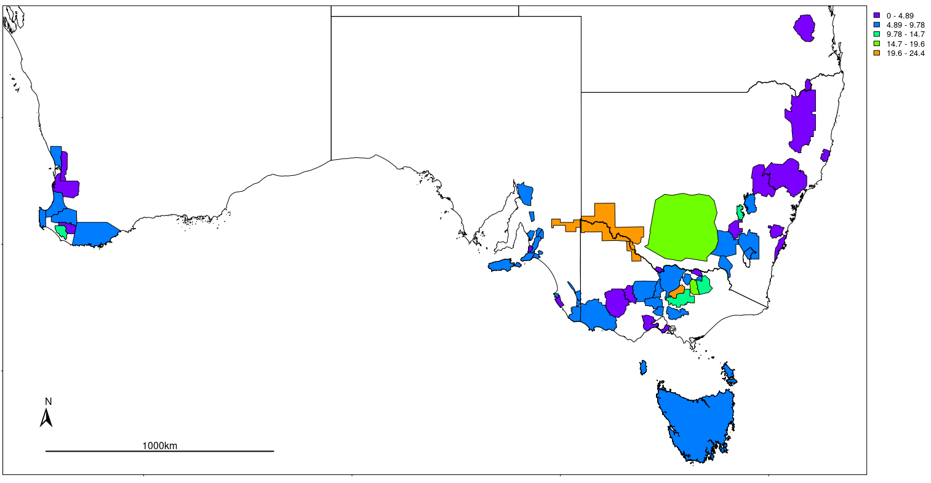

**Figure 6:** Average Price Per Tonne for each GI Region

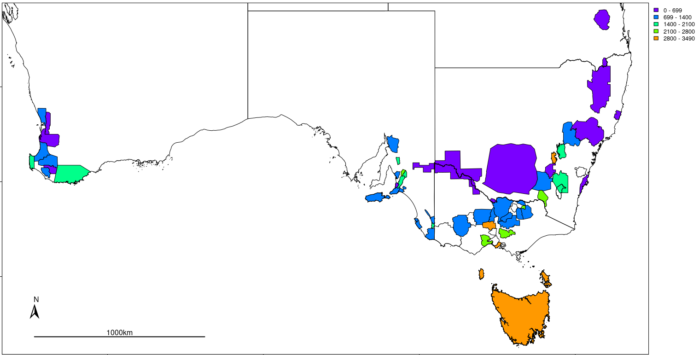

Although the initial correlation between average sales price and yield was a negative trend (see table 2), these models were able to shed light on several contributing factors to yield and average sales price. Correlation values showed that water and emissions increased with yield but decreased with average sale price (see Table 4). In alternative attempts at models it was found that without the incorporation of GI Region or year the predictions greatly under performed. The possible reason behind this effect was that different strategies are likely employed between different regions, where some regions target the mass production of cheaper grapes over quality. This is most notable when grouping regions by climate, especially when considering GI Regions in the ‘Hot Very Dry’ climate (see Figure 7). The effect of climate when used in models was not more significant than the more granular use of GI regions. The interaction between year and GI Region likely accounted for localised events such as bushfires, which would be impactful, but only at a local level in both time and space.

**Figure 7:** Value of tonnes harvested per hectare against the yield per hectare. With the variable transformed, with means centred on zero and scaled by standard deviation.

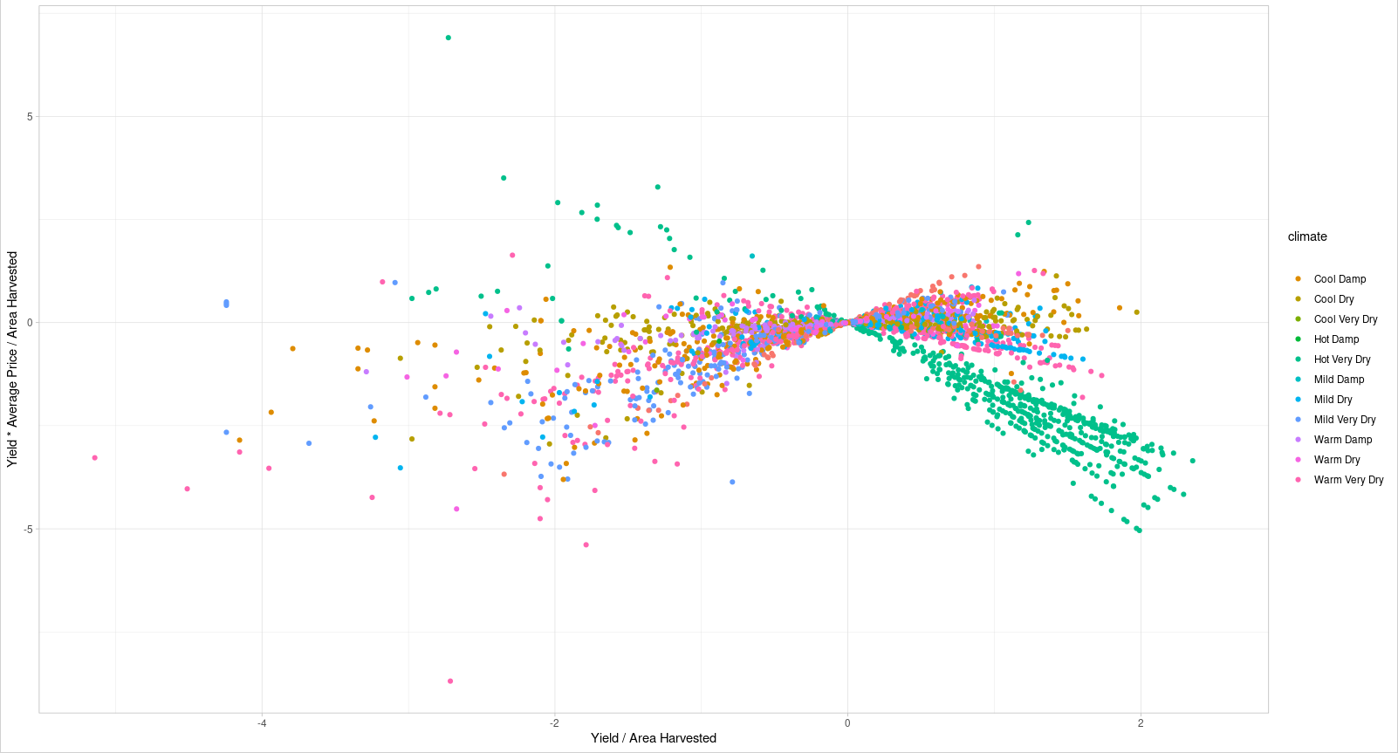

**Model Validation**

To validate the performance of these models k-fold cross validation was used. This was done using 10 folds, k=10, repeated 100 times. The models performed similarly to their original counter parts (see Table 11).

**Table 11:** Model validation using k-fold cross validation, for 10 folds repeated 100 times.

|  |  |  |  |
| --- | --- | --- | --- |
|  | **RMSE** | **R2** | **MAE** |
| **Model 1** | 3.087E-01 | 9.045E-01 | 2.165E-01 |
| **Model 2** | 5.104E-01 | 7.409E-01 | 3.493E-01 |
| **Model 3** | 1.652E-01 | 9.723E-01 | 1.008E-01 |
| **Model 4** | 2.235E-01 | 9.500E-01 | 1.279E-01 |

**Discussion**

This study investigated the general relationships between input resources of a vineyard, including fuel and water, and the outputs including yield and value. Some regions appeared to produce many low quality grapes at scale compared to attempting to produce fewer higher quality grapes. This behaviour can be observed when reviewing Wine Australia’s annual reports, where it is apparent that warm inland regions such as the Riverland are known to only produce large amounts of lower graded grapes (Wine Australia, 2022; Winemakers’ Federation of Australia, 2017). Comparatively, regions such as Tasmania only produce A grade grapes but in much smaller quantities than the Riverland. Knowing that the difference in pricing per tonne can exceed a magnitude of 10 between grades E and A, the operations in regions that target different grades would have varied priorities. However, some regions such as the Yarra Valley produce a Variety of different grades of grapes, from C to A, highlighting that vineyard priorities, although may be somewhat present within regional classifications, are not necessarily aligned within a given region.

The opportunity to target different grades of grapes may not always be available, with some regions being more renowned than others, and likely to be sought after regardless (Halliday, 2009). The Barossa is an example of this, known for its quality could also lend itself to a bias in purchasers not considering other regions that may be capable of similar quality. This effect could stifle the potential for market opportunities within these lesser known regions. A further possibility is that there may be regional upper limits with the relationship between resource input and the value gained becoming no longer proportional due to diminishing returns. Climate was considered to be a large determinant of the ability to grow a larger quantity of grapes, as well as a determinant in grape quality (Agosta et al., 2012); however there were vineyards in similar regions that were able to produce exceptionally better results than others (See Figure 7).

The issue of model 1 and 2 over predicting yield, may have been due to preventative measures brought on by regional pressures such as fire, frost and disease. Where, more resources were required to prevent these issues from spreading within a region, thus disproportionately effecting some vineyards compared to others locally. This type of maintenance is not well captured especially when considering that some regions, those in warmer areas are not as prone to disease as cooler climates and could potentially have lower operating costs per hectare. This could create a discrepancy in vineyards that utilise preventative measures in wetter regions, as opposed to those who do not, and thus expend less fuel and energy but risk disease. When reviewing the differences between regions it is important to consider that vineyards in Hot Very Dry areas can be hundreds of times the size of those in other regions. It is interesting that while area, although significantly correlated to the ratio of yield to area, was still lower than water and about the same as emissions. This points to economies of scale playing a role but still being only one consideration alongside the potential resources that can be used. The negative trend between size and average sales price could also be a side effect of mass supply verse demand, especially when looking at the level of difference in production of some vineyards (see Table 4). The relationships between yield, value and area are not simply about efficiently producing the most grapes; sales price and by association grape quality, are integral to the profitability, and this is strongly linked to resource use and thus the longevity and sustainability of a vineyard.

Literature shows that there are many on-the-ground decisions that influence both quality and yield. Where these decisions are governed by complex physical and social forces such as international market demands, disease pressures and natural disasters (Abad et al., 2021; Cortez et al., 2009; Hall et al., 2011; I. Goodwin, et al., 2009; Kasimati et al., 2022; Oliver et al., 2013; Srivastava and Sadistap, 2018). Many of these occurrences being highlighted throughout the past decades vintage reports (Wine Australia, 2022, 2021, 2020, 2019; Winemakers’ Federation of Australia, 2018, 2017, 2016, 2015, 2014, 2013, 2012). It is also important to consider that these reports show that the warm inland regions have seen a decline in profit during this period, as they were often compared to other regions that focused more on quality than quantity. This is an important consideration, as the size of some of these vineyards when considering their ratio of value to area would only require a marginal increase to out compete other regions. There are also differences when comparing winegrowers to other agricultural industries as they are vertically integrated within the wine industry, tying them to secondary and tertiary industries, such as wine production, packaging, transport and sales. This results in unique issues and considerations for each vineyard, where these on-the-ground decisions may be influenced by other wine industry’s choices, such as the use of sustainable practices in vineyards as a requirement for sale in overseas markets; notably these interactions are further complicated by some winegrowers being totally integrated into wine companies, while others are not (Knight et al., 2019). Incorporating such decisions into the model could help describe the contributing factors to regional differences beyond resource consumption and regional differences.

Having more data for each region would also be an improvement, allowing greater comparison between regions. More variables may also help to discern vineyards that can produce larger volumes of grapes at higher prices. The use of semi transparent tools such as random forests and decision trees alongside more variables and data may help to uncover the reasons for values that were under or over estimated. These differences could be caused by the use of alternative sustainable practices in the field. While there is evidence to suggest that environmentally sustainable practices can reduce costs, increase efficiency, whilst improving the quality of grapes, more research is needed to link these benefits across different regions and climates (Baiano, 2021; Mariani and Vastola, 2015; Montalvo-Falcón et al., 2023).

**References**

Abad, J., Hermoso de Mendoza, I., Marín, D., Orcaray, L., Santesteban, L.G., 2021. Cover crops in viticulture. A systematic review (1): <br>Implications on soil characteristics and biodiversity in vineyard. OENO One 55, 295–312. https://doi.org/10.20870/oeno-one.2021.55.1.3599

Abbal, P., Sablayrolles, J.-M., Matzner-Lober, É., Boursiquot, J.-M., Baudrit, C., Carbonneau, A., 2016. Decision Support System for Vine Growers Based on a Bayesian Network. J. Agric. Biol. Environ. Stat. 21, 131–151. https://doi.org/10.1007/s13253-015-0233-2

Agosta, E., Canziani, P., Cavagnaro, M., 2012. Regional climate variability impacts on the annual grape yield in Mendoza, Argentina. J. Appl. Meteorol. Climatol. 51, 993–1009.

Baiano, A., 2021. An Overview on Sustainability in the Wine Production Chain. Beverages 7. https://doi.org/10.3390/beverages7010015

Cortez, P., Teixeira, J., Cerdeira, A., Almeida, F., Matos, T., Reis, J., 2009. Using data mining for wine quality assessment, in: Discovery Science: 12th International Conference, DS 2009, Porto, Portugal, October 3-5, 2009 12. Springer, pp. 66–79.

Department of Climate Change, Energy, the Environment and Water, 2022. Australian National Greenhouse Accounts Factors.

Fraga, H., Costa, R., Santos, J.A., 2017. Multivariate clustering of viticultural terroirs in the Douro winemaking region. Ciênc. Téc Vitiv 32, 142–153.

G. van Rossum, 1995. Python tutorial, Technical Report CS-R9526.

Hall, A., Lamb, D.W., Holzapfel, B.P., Louis, J.P., 2011. Within-season temporal variation in correlations between vineyard canopy and winegrape composition and yield. Precis. Agric. 12, 103–117.

Halliday, J.C. (James C.), 2009. Australian Wine Encyclopedia. Hardie Grant Books, VIC.

I. Goodwin, L. McClymont, D. Lanyon, A. Zerihun, J. Hornbuckle, M. Gibberd, D. Mowat, D. Smith, M. Barnes, R. Correll, 2009. Managing soil and water to target quality and reduce environmental impact.

Kasimati, A., Espejo-García, B., Darra, N., Fountas, S., 2022. Predicting Grape Sugar Content under Quality Attributes Using Normalized Difference Vegetation Index Data and Automated Machine Learning. Sensors 22. https://doi.org/10.3390/s22093249

Keith Jones, 2002. Australian Wine Industry Environment Strategy.

Knight, H., Megicks, P., Agarwal, S., Leenders, M.A.A.M., 2019. Firm resources and the development of environmental sustainability among small and medium-sized enterprises: Evidence from the Australian wine industry. Bus. Strategy Environ. 28, 25–39. https://doi.org/10.1002/bse.2178

Kuhn, M., 2008. Building Predictive Models in R Using the caret Package. J. Stat. Softw. Artic. 28, 1–26. https://doi.org/10.18637/jss.v028.i05

Mariani, A., Vastola, A., 2015. Sustainable winegrowing: Current perspectives. Int. J. Wine Res. 7, 37–48.

Montalvo-Falcón, J.V., Sánchez-García, E., Marco-Lajara, B., Martínez-Falcó, J., 2023. Sustainability Research in the Wine Industry: A Bibliometric Approach. Agronomy 13. https://doi.org/10.3390/agronomy13030871

Oliver, D.P., Bramley, R.G.V., Riches, D., Porter, I., Edwards, J., 2013. Review: soil physical and chemical properties as indicators of soil quality in Australian viticulture. Aust. J. Grape Wine Res. 19, 129–139. https://doi.org/10.1111/ajgw.12016

R Core Team, 2021. R: A Language and Environment for Statistical Computing.

SOAR, C.J., SADRAS, V.O., PETRIE, P.R., 2008. Climate drivers of red wine quality in four contrasting Australian wine regions. Aust. J. Grape Wine Res. 14, 78–90. https://doi.org/10.1111/j.1755-0238.2008.00011.x

Srivastava, S., Sadistap, S., 2018. Non-destructive sensing methods for quality assessment of on-tree fruits: a review. J. Food Meas. Charact. 12, 497–526.

SWA, S.W.A., 2022. Sustainable Wingrowing Australia [WWW Document]. Case Stud. URL https://sustainablewinegrowing.com.au/case-studies/ (accessed 11.5.22).

SWA, S.W.A., 2021. Sustainable Winegrowing Australia User Manual.

Toumbourou, J.W., Rowland, B., Ghayour-Minaie, M., Sherker, S., Patton, G.C., Williams, J.W., 2018. Student survey trends in reported alcohol use and influencing factors in Australia. Drug Alcohol Rev. 37, S58–S66. https://doi.org/10.1111/dar.12645

Wine Australia, 2022. National Vintage Report 2022.

Wine Australia, 2021. National Vintage Report 2021.

Wine Australia, 2020. National Vintage Report 2020.

Wine Australia, 2019. National Vintage Report 2019.

Winemakers’ Federation of Australia, 2018. National Vintage Report 2018.

Winemakers’ Federation of Australia, 2017. National Vintage Report 2017.

Winemakers’ Federation of Australia, 2016. National Vintage Report 2016.

Winemakers’ Federation of Australia, 2015. National Vintage Report 2015.

Winemakers’ Federation of Australia, 2014. National Vintage Report 2014.

Winemakers’ Federation of Australia, 2013. National Vintage Report 2013.

Winemakers’ Federation of Australia, 2012. National Vintage Report 2012.